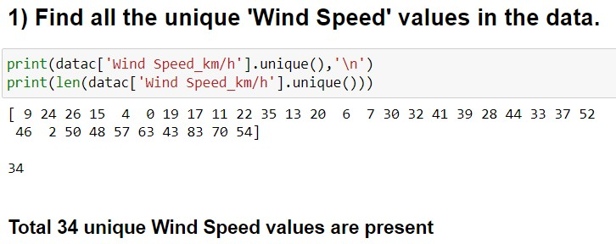

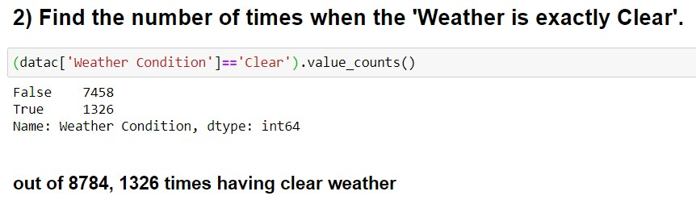

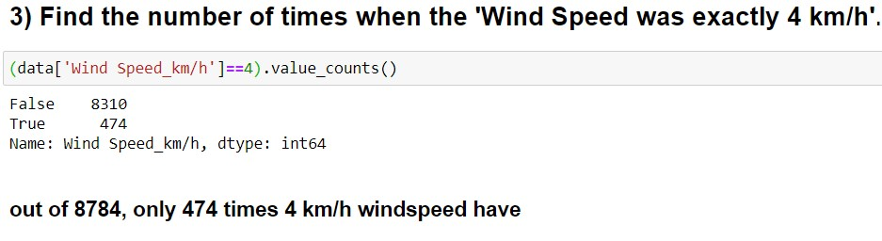

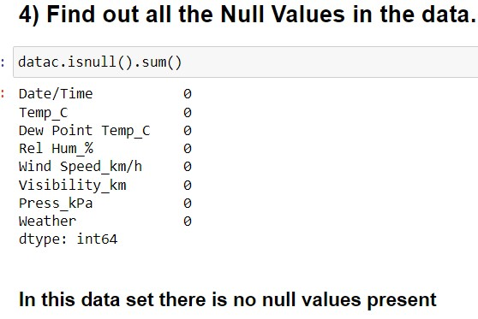

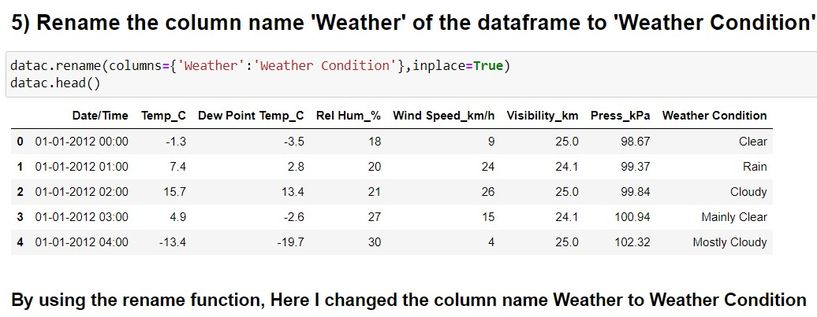

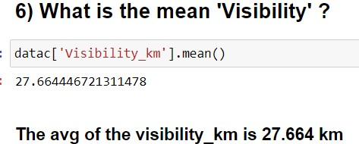

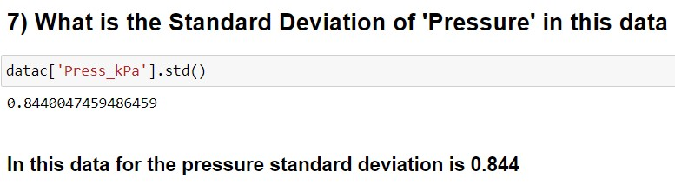

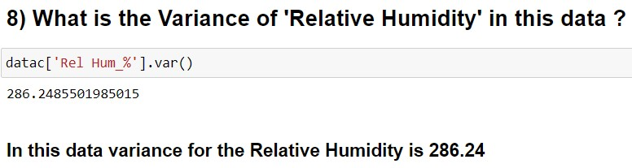

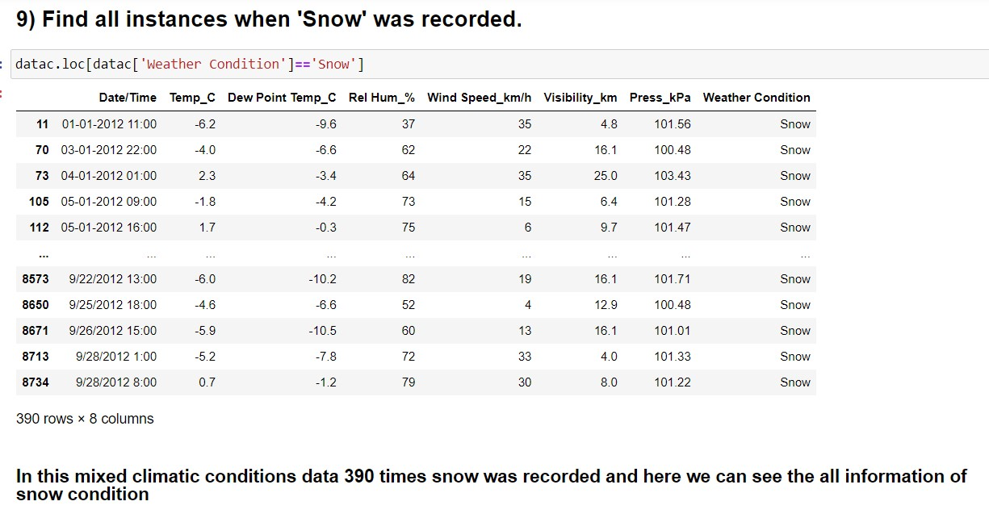

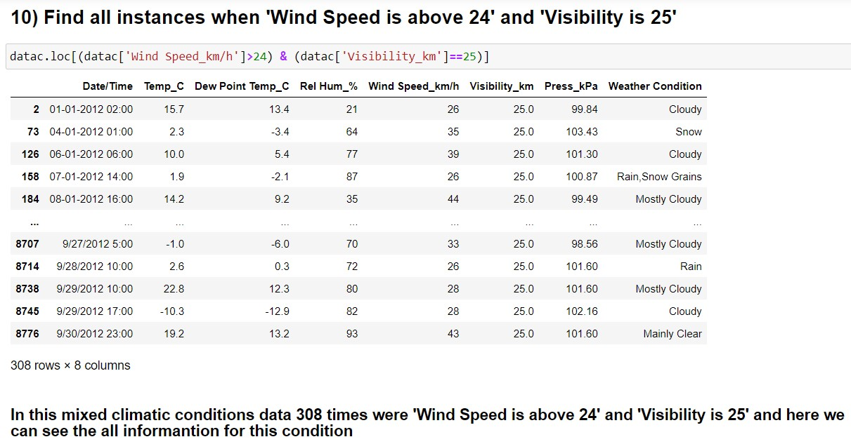



|  | **Temp_C** | **Dew Point Temp_C** | **Rel Hum_%** | **Wind Speed_km/h** | **Visibility_km** | **Press_kPa** |
| --- | --- | --- | --- | --- | --- | --- |
| **Weather Condition** |  |  |  |  |  |  |
| **Clear** | 6.825716 | 0.089367 | 67.127451 | 10.557315 | 30.153243 | 101.084495 |
| **Cloudy** | 7.970544 | 2.375810 | 67.349537 | 16.127315 | 26.625752 | 101.056852 |
| **Drizzle** | 7.353659 | 5.504878 | 69.048780 | 16.097561 | 17.931707 | 101.099268 |
| **Drizzle,Fog** | 8.067500 | 7.033750 | 70.062500 | 11.862500 | 5.257500 | 100.820750 |
| **Drizzle,Ice Pellets,Fog** | 0.400000 | -0.700000 | 52.000000 | 20.000000 | 4.000000 | 99.440000 |
| **Drizzle,Snow** | 1.050000 | 0.150000 | 44.000000 | 14.000000 | 10.500000 | 100.490000 |
| **Drizzle,Snow,Fog** | 0.693333 | 0.120000 | 69.800000 | 15.533333 | 5.513333 | 100.971333 |
| **Fog** | 4.303333 | 3.159333 | 66.466667 | 7.946667 | 6.248000 | 101.149400 |
| **Freezing Drizzle** | -5.657143 | -8.000000 | 68.857143 | 16.571429 | 9.200000 | 101.070000 |
| **Freezing Drizzle,Fog** | -2.533333 | -4.183333 | 64.000000 | 17.000000 | 5.266667 | 100.851667 |
| **Freezing Drizzle,Haze** | -5.433333 | -8.000000 | 63.333333 | 10.333333 | 2.666667 | 101.136667 |
| **Freezing Drizzle,Snow** | -5.109091 | -7.072727 | 62.454545 | 16.272727 | 5.872727 | 100.380909 |
| **Freezing Fog** | -7.575000 | -9.250000 | 68.000000 | 4.750000 | 0.650000 | 101.222500 |
| **Freezing Rain** | -3.885714 | -6.078571 | 60.785714 | 19.214286 | 8.242857 | 101.500714 |
| **Freezing Rain,Fog** | -2.225000 | -3.750000 | 52.750000 | 15.500000 | 7.550000 | 100.267500 |
| **Freezing Rain,Haze** | -4.900000 | -7.450000 | 63.000000 | 7.500000 | 2.400000 | 100.265000 |
| **Freezing Rain,Ice Pellets,Fog** | -2.600000 | -3.700000 | 65.000000 | 28.000000 | 8.000000 | 98.330000 |
| **Freezing Rain,Snow Grains** | -5.000000 | -7.300000 | 92.000000 | 32.000000 | 4.800000 | 102.520000 |
| **Haze** | -0.200000 | -2.975000 | 69.625000 | 10.437500 | 7.831250 | 100.805625 |
| **Mainly Clear** | 12.558927 | 4.581671 | 68.020893 | 14.144824 | 34.264862 | 101.040940 |
| **Moderate Rain,Fog** | 1.700000 | 0.800000 | 89.000000 | 17.000000 | 6.400000 | 100.450000 |
| **Moderate Snow** | -5.525000 | -7.250000 | 67.500000 | 33.750000 | 0.750000 | 100.760000 |
| **Moderate Snow,Blowing Snow** | -5.450000 | -6.500000 | 81.500000 | 40.000000 | 0.600000 | 102.215000 |
| **Mostly Cloudy** | 10.574287 | 3.131174 | 67.214113 | 15.813920 | 31.253842 | 101.051054 |
| **Rain** | 9.786275 | 7.042810 | 67.614379 | 19.254902 | 18.856536 | 101.051797 |
| **Rain Showers** | 13.722340 | 9.187766 | 68.335106 | 17.132979 | 22.816489 | 101.020106 |
| **Rain Showers,Fog** | 12.800000 | 12.100000 | 31.000000 | 13.000000 | 6.400000 | 99.800000 |
| **Rain Showers,Snow Showers** | 2.150000 | -1.500000 | 68.500000 | 22.500000 | 21.700000 | 101.080000 |
| **Rain,Fog** | 8.273276 | 7.219828 | 66.818966 | 14.793103 | 6.873276 | 100.991983 |
| **Rain,Haze** | 4.633333 | 2.066667 | 57.666667 | 11.666667 | 6.700000 | 100.716667 |
| **Rain,Ice Pellets** | 0.600000 | -0.600000 | 54.000000 | 24.000000 | 9.700000 | 101.880000 |
| **Rain,Snow** | 1.055556 | -0.566667 | 66.944444 | 28.388889 | 11.672222 | 100.895000 |
| **Rain,Snow Grains** | 1.900000 | -2.100000 | 87.000000 | 26.000000 | 25.000000 | 100.870000 |
| **Rain,Snow,Fog** | 0.800000 | 0.300000 | 61.000000 | 9.000000 | 6.400000 | 102.480000 |
| **Rain,Snow,Ice Pellets** | 1.100000 | -0.175000 | 72.500000 | 23.250000 | 6.000000 | 101.170000 |
| **Snow** | -4.524103 | -7.623333 | 66.402564 | 20.038462 | 11.171795 | 101.077205 |
| **Snow Pellets** | 0.700000 | -6.400000 | 66.000000 | 35.000000 | 2.400000 | 99.560000 |
| **Snow Showers** | -3.506667 | -7.866667 | 65.600000 | 19.233333 | 20.158333 | 100.999333 |
| **Snow Showers,Fog** | -10.675000 | -11.900000 | 63.750000 | 13.750000 | 7.025000 | 100.770000 |
| **Snow,Blowing Snow** | -5.410526 | -7.621053 | 72.631579 | 34.842105 | 4.105263 | 101.032105 |
| **Snow,Fog** | -5.075676 | -6.364865 | 70.459459 | 17.324324 | 4.537838 | 101.194865 |
| **Snow,Haze** | -4.020000 | -6.860000 | 66.000000 | 5.000000 | 4.640000 | 100.360000 |
| **Snow,Ice Pellets** | -1.883333 | -3.666667 | 74.000000 | 23.833333 | 7.416667 | 100.746667 |
| **Thunderstorms** | 24.150000 | 19.750000 | 56.500000 | 7.500000 | 24.550000 | 101.375000 |
| **Thunderstorms,Heavy Rain Showers** | 10.900000 | 9.000000 | 82.000000 | 9.000000 | 2.400000 | 101.400000 |
| **Thunderstorms,Moderate Rain Showers,Fog** | 19.600000 | 18.500000 | 58.000000 | 15.000000 | 3.200000 | 99.940000 |
| **Thunderstorms,Rain** | 20.433333 | 18.533333 | 71.666667 | 15.666667 | 19.833333 | 101.536667 |
| **Thunderstorms,Rain Showers** | 20.037500 | 17.618750 | 68.437500 | 18.312500 | 15.893750 | 100.976875 |
| **Thunderstorms,Rain Showers,Fog** | 21.600000 | 18.700000 | 58.666667 | 19.666667 | 9.700000 | 100.806667 |
| **Thunderstorms,Rain,Fog** | 20.600000 | 18.600000 | 42.000000 | 19.000000 | 4.800000 | 100.450000 |

**Here we can see that avg for every weather condition in different climatic situations**



| **Date/Time** | | **Temp_C** | | **Dew Point Temp_C** | | **Rel Hum_%** | | **Wind Speed_km/h** | | **Visibility_km** | | **Press_kPa** | |
| --- | --- | --- | --- | --- | --- | --- | --- | --- | --- | --- | --- | --- | --- |
|  | **min** | **max** | **min** | **max** | **min** | **max** | **min** | **max** | **min** | **max** | **min** | **max** | **min** | **max** |
| **Weather Condition** |  |  |  |  |  |  |  |  |  |  |  |  |  |  |
| **Clear** | 01-01-2012 00:00 | 9/30/2012 7:00 | -23.3 | 32.8 | -28.5 | 20.4 | 18 | 100 | 0 | 33 | 11.3 | 48.3 | 97.75 | 103.63 |
| **Cloudy** | 01-01-2012 02:00 | 9/30/2012 8:00 | -21.4 | 30.5 | -26.8 | 22.6 | 20 | 100 | 0 | 54 | 11.3 | 48.3 | 97.52 | 103.52 |
| **Drizzle** | 01-06-2012 08:00 | 9/15/2012 22:00 | 1.1 | 18.8 | -0.2 | 17.7 | 37 | 97 | 0 | 30 | 6.4 | 25.0 | 98.29 | 103.58 |
| **Drizzle,Fog** | 01-04-2012 01:00 | 9/19/2012 15:00 | 0.0 | 19.9 | -1.6 | 19.1 | 38 | 98 | 0 | 28 | 1.0 | 9.7 | 98.32 | 103.56 |
| **Drizzle,Ice Pellets,Fog** | 7/24/2012 5:00 | 7/24/2012 5:00 | 0.4 | 0.4 | -0.7 | -0.7 | 52 | 52 | 20 | 20 | 4.0 | 4.0 | 99.44 | 99.44 |
| **Drizzle,Snow** | 05-02-2012 09:00 | 3/17/2012 1:00 | 0.9 | 1.2 | 0.1 | 0.2 | 39 | 49 | 9 | 19 | 9.7 | 11.3 | 100.27 | 100.71 |
| **Drizzle,Snow,Fog** | 03-11-2012 20:00 | 9/21/2012 12:00 | 0.3 | 1.1 | -0.1 | 0.6 | 46 | 94 | 7 | 32 | 2.4 | 9.7 | 99.26 | 102.47 |
| **Fog** | 01-01-2012 13:00 | 9/30/2012 19:00 | -16.0 | 20.8 | -17.2 | 19.6 | 21 | 99 | 0 | 22 | 0.2 | 9.7 | 97.97 | 103.22 |
| **Freezing Drizzle** | 04-01-2012 03:00 | 8/21/2012 5:00 | -9.0 | -2.3 | -12.2 | -3.3 | 43 | 89 | 6 | 26 | 4.8 | 12.9 | 99.75 | 101.78 |
| **Freezing Drizzle,Fog** | 10/15/2012 4:00 | 7/26/2012 6:00 | -6.4 | -0.3 | -9.0 | -2.3 | 31 | 80 | 6 | 33 | 3.6 | 8.0 | 98.81 | 103.01 |
| **Freezing Drizzle,Haze** | 01-06-2012 00:00 | 5/21/2012 4:00 | -5.8 | -5.0 | -8.3 | -7.7 | 32 | 81 | 9 | 11 | 2.0 | 4.0 | 100.55 | 101.83 |
| **Freezing Drizzle,Snow** | 02-06-2012 07:00 | 8/18/2012 4:00 | -8.3 | -3.3 | -10.4 | -4.6 | 37 | 90 | 6 | 24 | 2.4 | 12.9 | 99.74 | 101.15 |
| **Freezing Fog** | 12/31/2012 2:00 | 5/14/2012 9:00 | -19.0 | -0.1 | -22.9 | -0.3 | 34 | 86 | 0 | 9 | 0.2 | 0.8 | 100.66 | 101.64 |
| **Freezing Rain** | 01-03-2012 13:00 | 8/22/2012 10:00 | -6.5 | 0.3 | -9.0 | -1.7 | 40 | 100 | 7 | 28 | 2.8 | 16.1 | 100.92 | 102.45 |
| **Freezing Rain,Fog** | 07-05-2012 15:00 | 5/16/2012 23:00 | -6.1 | 0.1 | -8.7 | -0.9 | 35 | 77 | 7 | 26 | 2.8 | 9.7 | 99.45 | 101.21 |
| **Freezing Rain,Haze** | 11/23/2012 7:00 | 3/25/2012 23:00 | -4.9 | -4.9 | -7.5 | -7.4 | 57 | 69 | 6 | 9 | 2.0 | 2.8 | 100.23 | 100.30 |
| **Freezing Rain,Ice Pellets,Fog** | 8/16/2012 23:00 | 8/16/2012 23:00 | -2.6 | -2.6 | -3.7 | -3.7 | 65 | 65 | 28 | 28 | 8.0 | 8.0 | 98.33 | 98.33 |
| **Freezing Rain,Snow Grains** | 04-02-2012 07:00 | 04-02-2012 07:00 | -5.0 | -5.0 | -7.3 | -7.3 | 92 | 92 | 32 | 32 | 4.8 | 4.8 | 102.52 | 102.52 |
| **Haze** | 01-02-2012 17:00 | 9/25/2012 15:00 | -11.5 | 14.1 | -16.0 | 11.1 | 37 | 98 | 0 | 17 | 4.8 | 9.7 | 99.27 | 103.29 |
| **Mainly Clear** | 01-01-2012 03:00 | 9/30/2012 3:00 | -22.8 | 33.0 | -28.0 | 21.2 | 20 | 100 | 0 | 63 | 12.9 | 48.3 | 97.84 | 103.65 |
| **Moderate Rain,Fog** | 8/20/2012 16:00 | 8/20/2012 16:00 | 1.7 | 1.7 | 0.8 | 0.8 | 89 | 89 | 17 | 17 | 6.4 | 6.4 | 100.45 | 100.45 |
| **Moderate Snow** | 10-11-2012 22:00 | 6/17/2012 14:00 | -6.3 | -4.9 | -7.6 | -6.7 | 29 | 85 | 26 | 39 | 0.6 | 0.8 | 99.93 | 101.96 |
| **Moderate Snow,Blowing Snow** | 06-07-2012 08:00 | 6/26/2012 2:00 | -5.5 | -5.4 | -6.6 | -6.4 | 67 | 96 | 39 | 41 | 0.6 | 0.6 | 101.97 | 102.46 |
| **Mostly Cloudy** | 01-01-2012 04:00 | 9/30/2012 9:00 | -23.2 | 32.4 | -28.5 | 24.4 | 18 | 100 | 0 | 83 | 11.3 | 48.3 | 97.56 | 103.63 |
| **Rain** | 01-01-2012 01:00 | 9/30/2012 0:00 | 0.3 | 22.8 | -5.7 | 20.4 | 20 | 97 | 0 | 52 | 4.0 | 48.3 | 98.06 | 103.59 |
| **Rain Showers** | 01-03-2012 11:00 | 9/29/2012 7:00 | 1.6 | 26.4 | -7.2 | 23.0 | 24 | 99 | 0 | 41 | 6.4 | 48.3 | 97.93 | 103.65 |
| **Rain Showers,Fog** | 12/17/2012 16:00 | 12/17/2012 16:00 | 12.8 | 12.8 | 12.1 | 12.1 | 31 | 31 | 13 | 13 | 6.4 | 6.4 | 99.80 | 99.80 |
| **Rain Showers,Snow Showers** | 8/31/2012 11:00 | 8/31/2012 7:00 | 2.1 | 2.2 | -1.8 | -1.2 | 67 | 70 | 17 | 28 | 19.3 | 24.1 | 100.54 | 101.62 |
| **Rain,Fog** | 01-02-2012 12:00 | 9/29/2012 11:00 | 0.0 | 21.7 | -1.2 | 19.5 | 23 | 93 | 0 | 46 | 2.0 | 9.7 | 98.70 | 102.71 |
| **Rain,Haze** | 01-02-2012 19:00 | 12-10-2012 11:00 | 4.0 | 5.5 | 1.0 | 2.9 | 40 | 75 | 7 | 17 | 4.0 | 9.7 | 99.89 | 101.52 |
| **Rain,Ice Pellets** | 10-03-2012 01:00 | 10-03-2012 01:00 | 0.6 | 0.6 | -0.6 | -0.6 | 54 | 54 | 24 | 24 | 9.7 | 9.7 | 101.88 | 101.88 |
| **Rain,Snow** | 04-09-2012 20:00 | 9/26/2012 11:00 | 0.6 | 1.7 | -1.7 | 0.5 | 31 | 93 | 13 | 52 | 2.4 | 25.0 | 100.03 | 102.21 |
| **Rain,Snow Grains** | 07-01-2012 14:00 | 07-01-2012 14:00 | 1.9 | 1.9 | -2.1 | -2.1 | 87 | 87 | 26 | 26 | 25.0 | 25.0 | 100.87 | 100.87 |
| **Rain,Snow,Fog** | 05-10-2012 03:00 | 05-10-2012 03:00 | 0.8 | 0.8 | 0.3 | 0.3 | 61 | 61 | 9 | 9 | 6.4 | 6.4 | 102.48 | 102.48 |
| **Rain,Snow,Ice Pellets** | 02-09-2012 11:00 | 7/19/2012 22:00 | 0.9 | 1.3 | -0.7 | 0.1 | 53 | 86 | 17 | 28 | 4.8 | 6.4 | 100.30 | 101.90 |
| **Snow** | 01-01-2012 11:00 | 9/28/2012 8:00 | -16.7 | 3.7 | -24.6 | 0.3 | 20 | 100 | 0 | 57 | 1.0 | 25.0 | 97.99 | 103.65 |
| **Snow Pellets** | 7/19/2012 2:00 | 7/19/2012 2:00 | 0.7 | 0.7 | -6.4 | -6.4 | 66 | 66 | 35 | 35 | 2.4 | 2.4 | 99.56 | 99.56 |
| **Snow Showers** | 01-03-2012 05:00 | 8/31/2012 0:00 | -13.3 | 2.9 | -19.3 | -0.7 | 31 | 95 | 0 | 37 | 2.4 | 48.3 | 99.09 | 102.45 |
| **Snow Showers,Fog** | 1/20/2012 3:00 | 7/19/2012 13:00 | -11.3 | -10.0 | -12.7 | -11.1 | 56 | 76 | 7 | 22 | 4.0 | 9.7 | 100.33 | 101.48 |
| **Snow,Blowing Snow** | 01-09-2012 10:00 | 9/25/2012 9:00 | -12.0 | -1.4 | -16.2 | -2.9 | 44 | 97 | 24 | 48 | 0.6 | 9.7 | 99.23 | 103.59 |
| **Snow,Fog** | 01-02-2012 09:00 | 9/22/2012 12:00 | -10.1 | 1.1 | -12.0 | 0.8 | 38 | 99 | 4 | 35 | 1.2 | 9.7 | 99.60 | 103.51 |
| **Snow,Haze** | 01-06-2012 17:00 | 12/13/2012 14:00 | -4.3 | -3.6 | -7.2 | -6.4 | 48 | 83 | 0 | 15 | 4.0 | 6.4 | 98.58 | 101.90 |
| **Snow,Ice Pellets** | 01-03-2012 17:00 | 9/23/2012 20:00 | -4.3 | 0.8 | -5.9 | -1.7 | 50 | 92 | 19 | 33 | 2.8 | 11.3 | 100.13 | 101.73 |
| **Thunderstorms** | 11/29/2012 16:00 | 9/25/2012 5:00 | 21.6 | 26.7 | 19.4 | 20.1 | 56 | 57 | 0 | 15 | 24.1 | 25.0 | 100.86 | 101.89 |
| **Thunderstorms,Heavy Rain Showers** | 11-05-2012 12:00 | 11-05-2012 12:00 | 10.9 | 10.9 | 9.0 | 9.0 | 82 | 82 | 9 | 9 | 2.4 | 2.4 | 101.40 | 101.40 |
| **Thunderstorms,Moderate Rain Showers,Fog** | 10-01-2012 14:00 | 10-01-2012 14:00 | 19.6 | 19.6 | 18.5 | 18.5 | 58 | 58 | 15 | 15 | 3.2 | 3.2 | 99.94 | 99.94 |
| **Thunderstorms,Rain** | 10/23/2012 4:00 | 9/19/2012 14:00 | 19.4 | 21.3 | 18.2 | 19.1 | 64 | 80 | 4 | 30 | 16.1 | 24.1 | 100.56 | 102.82 |
| **Thunderstorms,Rain Showers** | 01-11-2012 11:00 | 9/17/2012 13:00 | 11.0 | 25.5 | 7.0 | 23.1 | 44 | 95 | 7 | 32 | 6.4 | 25.0 | 99.40 | 102.55 |
| **Thunderstorms,Rain Showers,Fog** | 08-01-2012 15:00 | 8/15/2012 9:00 | 19.5 | 22.9 | 16.1 | 21.3 | 34 | 82 | 7 | 35 | 9.7 | 9.7 | 99.33 | 101.77 |
| **Thunderstorms,Rain,Fog** | 11-04-2012 16:00 | 11-04-2012 16:00 | 20.6 | 20.6 | 18.6 | 18.6 | 42 | 42 | 19 | 19 | 4.8 | 4.8 | 100.45 | 100.45 |

**By using groupby here we got the max and min values of all climatic conditions in different weather conditions**

